LARAVEL CRUD LOGIN, JURUSAN DAN MAHASISWA

- LOGIN AUTH LARAVEL + Bootstrap tanpa Laravel Mix

🧱 STEP 1 — Buat Project Laravel
Buat projek baru. Contoh nama projek:akademiksaintek.
Masuk ke CMD dan jalankan command berikut:
Sebaiknya lokasi folder di Htdocs.
D:\xampp\htdocs
Command composer create-project --prefer-dist laravel/laravel akademiksaintek

🧱 STEP 2 —
Masuk folder project:
Command cd akademiksaintek

🧱 STEP 3 — Install Laravel UI
Jalankan command berikut:
Command composer require laravel/ui

🧱 STEP 4 — Generate Auth Login
Jalankan command berikut:
Command php artisan ui bootstrap –auth
Command tersebut otomatis akan membuat:
✅ Login
✅ Register
✅ Forgot Password
✅ Layout Bootstrap

🧱 STEP 5 — Modifikasi Layout utk Menambahkan Bootstrap
Buka file:
resources/views/layouts/app.blade.php
Hapus code bagian di bawah ini:
<link href="{{ asset('css/app.css') }}" rel="stylesheet">
<script src="{{ asset('js/app.js') }}" defer></script>

Atau jika menggunakan versi laravel yang menggunakan vite, hapus bagian tersebut.

🧱 STEP 6 — Pakai Bootstrap CDN Manual
Untuk menggunankan bootstrap, silakan Copas code berikut pada bagian yang dihapus di atas.
code lengkap resources/views/layouts/app.blade.php sbb:
<!doctype html>
<html lang="{{ str_replace('_', '-', app()->getLocale()) }}">

<head>
<meta charset="utf-8">
<meta name="viewport" content="width=device-width, initial-scale=1">

<!-- CSRF Token -->
<meta name="csrf-token" content="{{ csrf_token() }}">

<title>{{ config('app.name', 'AKADEMIK') }}</title>
<!-- Bootstrap CSS -->
<link href="https://cdn.jsdelivr.net/npm/bootstrap@5.1.3/dist/css/bootstrap.min.css" rel="stylesheet">

</head>

<body>
<div id="app">
<nav class="navbar navbar-expand-md navbar-light bg-white shadow-sm">
<div class="container">
<a class="navbar-brand" href="{{ url('/') }}">
AKADEMIK SAINTEK
</a>
<button class="navbar-toggler" type="button" data-bs-toggle="collapse" data-bs-target="#navbarSupportedContent" aria-controls="navbarSupportedContent" aria-expanded="false" aria-label="{{ __('Toggle navigation') }}">
<span class="navbar-toggler-icon"></span>
</button>

<div class="collapse navbar-collapse" id="navbarSupportedContent">
<!-- Left Side Of Navbar -->
<ul class="navbar-nav me-auto">

</ul>

<!-- Right Side Of Navbar -->
<ul class="navbar-nav ms-auto">
<!-- Authentication Links -->
@guest
@if (Route::has('login'))
<li class="nav-item">
<a class="nav-link" href="{{ route('login') }}">{{ __('Login') }}</a>
</li>
@endif

@if (Route::has('register'))
<li class="nav-item">
<a class="nav-link" href="{{ route('register') }}">{{ __('Register') }}</a>
</li>
@endif
@else
<li class="nav-item dropdown">
<a id="navbarDropdown" class="nav-link dropdown-toggle" href="#" role="button" data-bs-toggle="dropdown" aria-haspopup="true" aria-expanded="false" v-pre>
{{ Auth::user()->name }}
</a>

<div class="dropdown-menu dropdown-menu-end" aria-labelledby="navbarDropdown">
<a class="dropdown-item" href="{{ route('logout') }}"
onclick="event.preventDefault();
document.getElementById('logout-form').submit();">
{{ __('Logout') }}
</a>

<form id="logout-form" action="{{ route('logout') }}" method="POST" class="d-none">
@csrf
</form>
</div>
</li>
@endguest
</ul>
</div>
</div>
</nav>

<main class="py-4">
@yield('content')
</main>
</div>
<script src="https://cdn.jsdelivr.net/npm/bootstrap@5.1.3/dist/js/bootstrap.bundle.min.js"></script>

</body>

</html>

Note: Jika ingin menggunakan local bootstrap supaya tanpa perlu terkoneksi ke internet lg maka bisa dicopy source css dan script boostrap tersebut ke folder Public.

🧱 STEP 7 — Buat Database Baru
Buka dan masuk ke phpMyAdmin:
Buatlah database baru contoh akademiksaintek:
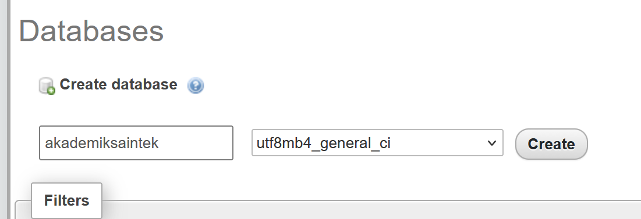
Atau jika menggunkan script sql Contoh dengan script:
CREATE DATABASE akademiksaintek;

🧱 STEP 8 — Setting Koneksi Database
Bukalah source code laravel dan modifikasi file: .env.
Sesuaikan nama dataabse ,user dan password databasenya.
DB_CONNECTION=mysql
DB_HOST=127.0.0.1
DB_PORT=3306
DB_DATABASE=akademiksaintek
DB_USERNAME=root
DB_PASSWORD=

🧱 STEP 9 — Migrasi Tabel User
Jalankan command berikut:
Command php artisan migrate
Command tsb akan membuat table sbb:
✅ users
✅ password_resets
✅ failed_jobs
Hasil migrasi:
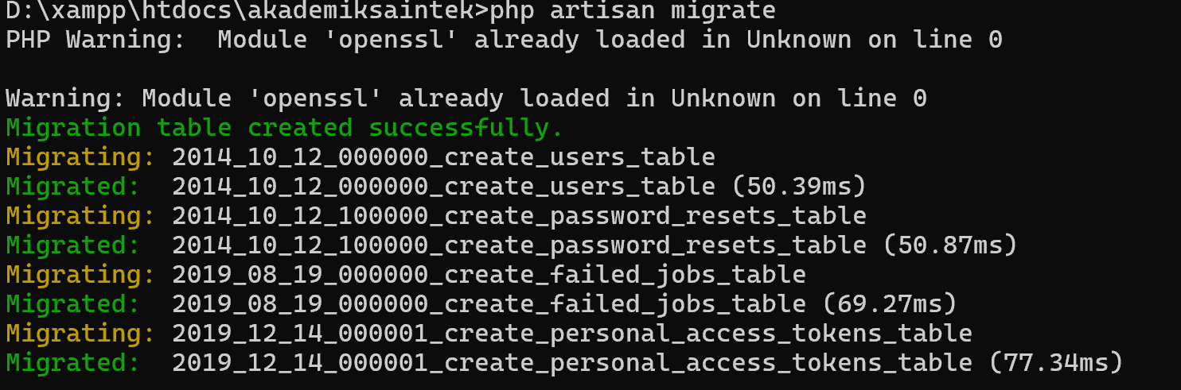

Cek database. Akan tergenerate bbrp table secara otomatis.
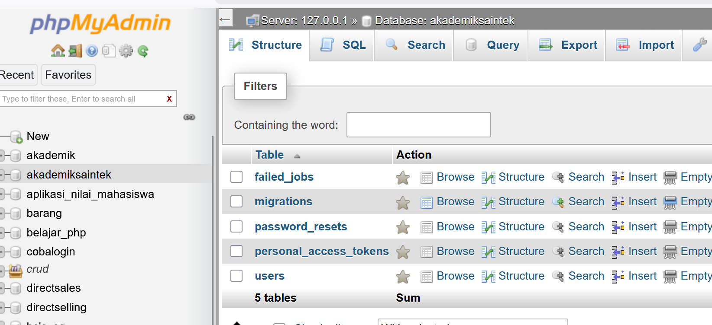

🧱 STEP 10 — Jalankan Laravel

Pada CMD jalankan command berikut:
Command php artisan serve
Buka browser dan jalankan melalui link berikut:
http://127.0.0.1:8000 atau

http://localhost:8000

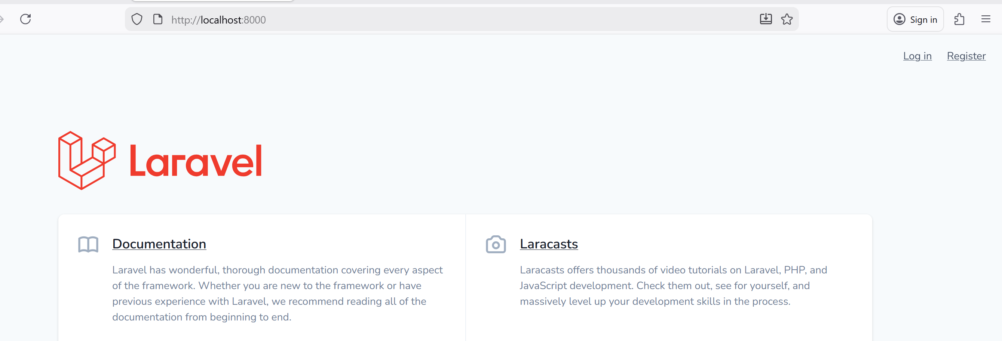

cobalah utk melakukan register dan login
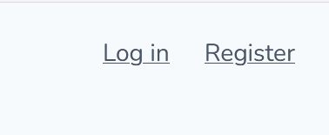

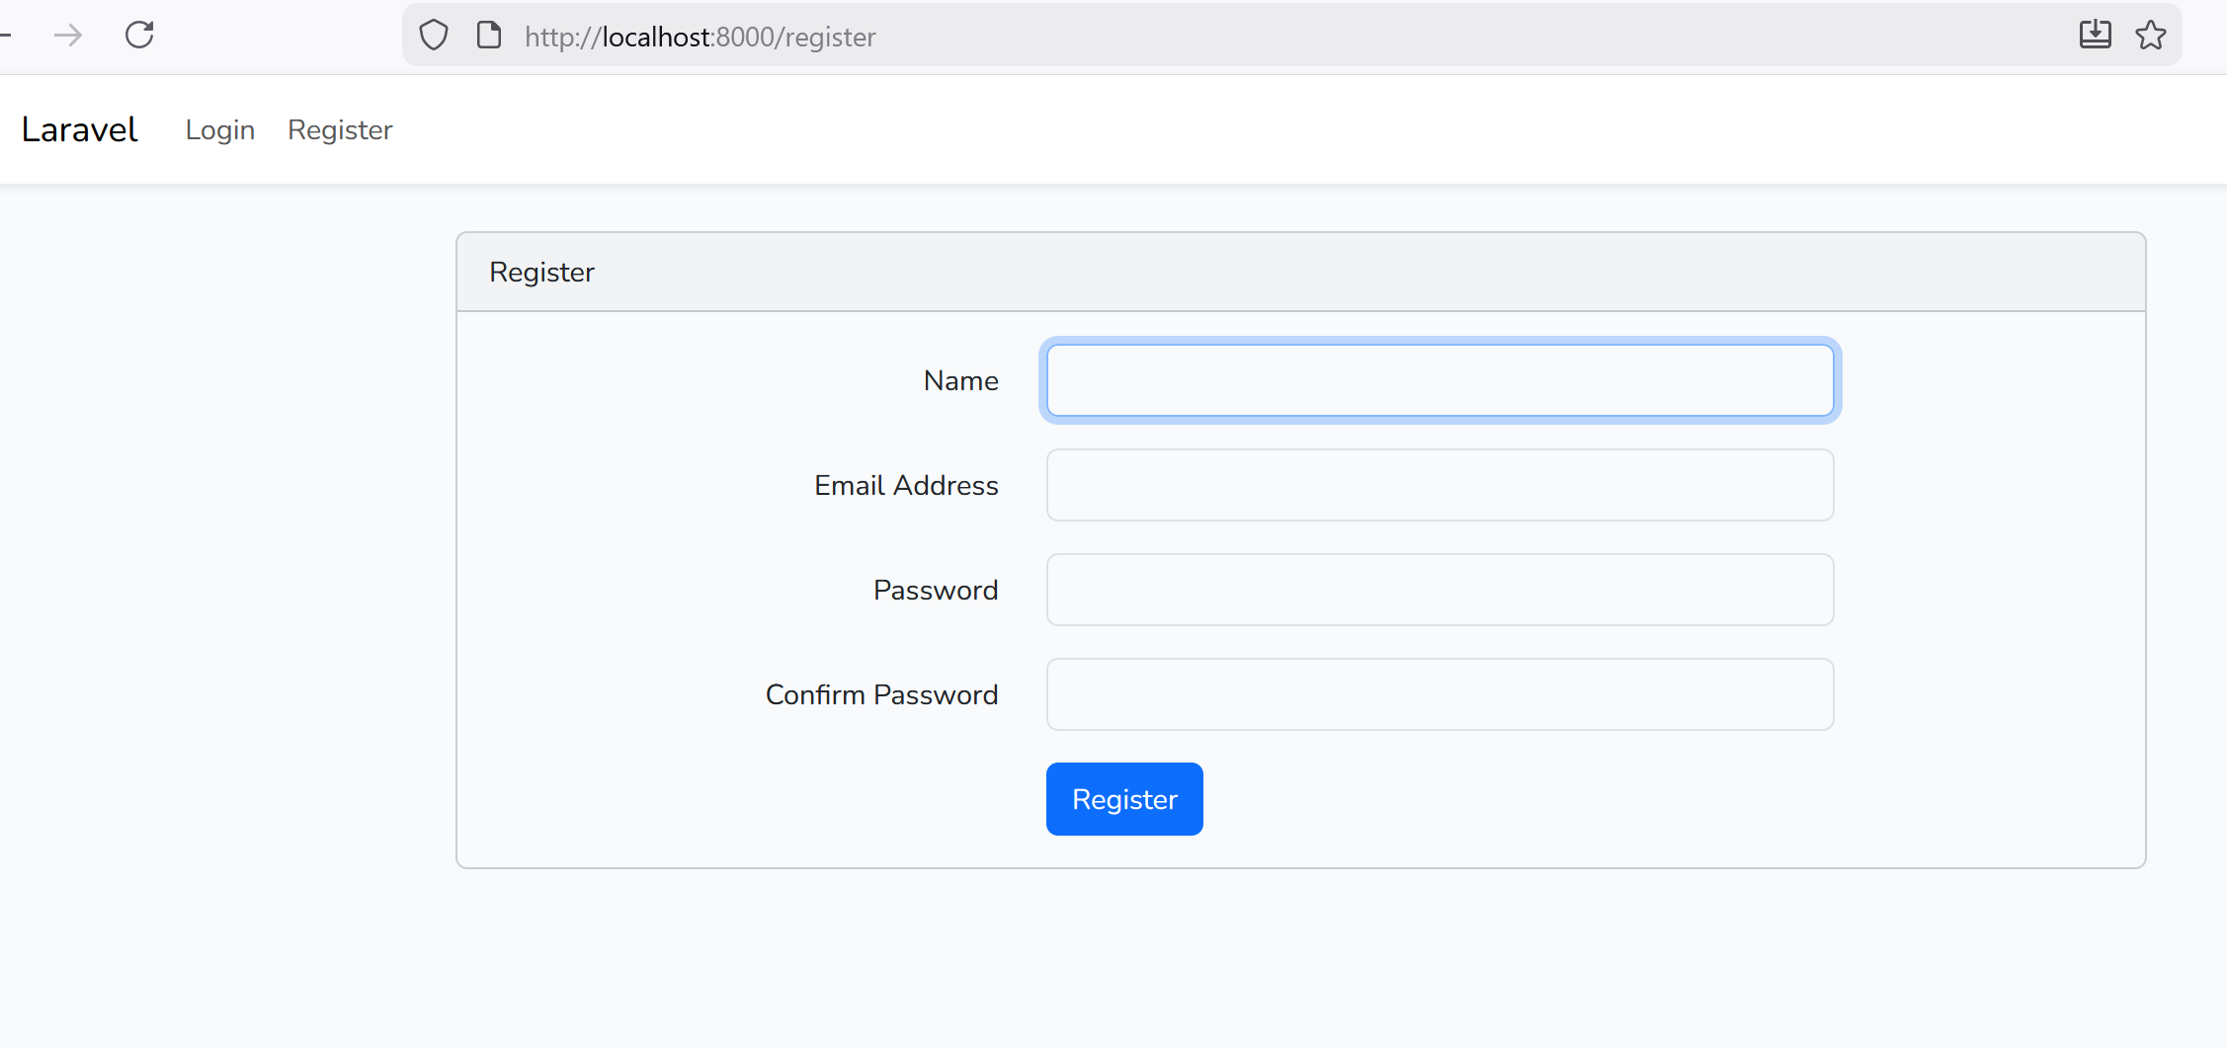
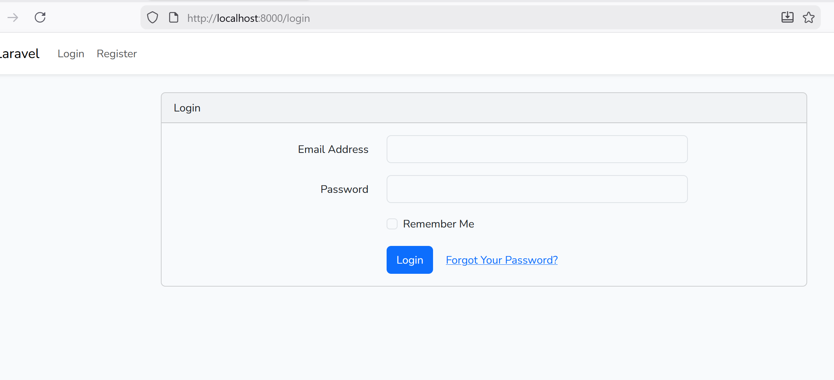

- MEMBUAT MENU JURUSAN

🧱 STEP 1 — Membuat Migration
Masuk CMD dan jalankan command berikut utk menggenerate file : --migration --controller –resource (mcr)
Command php artisan make:model Jurusan -mcr

🧱 STEP 2 —
Buka file migration Jurusan. File: database/migrations/ xxxx cereate_jurusan_table.php. 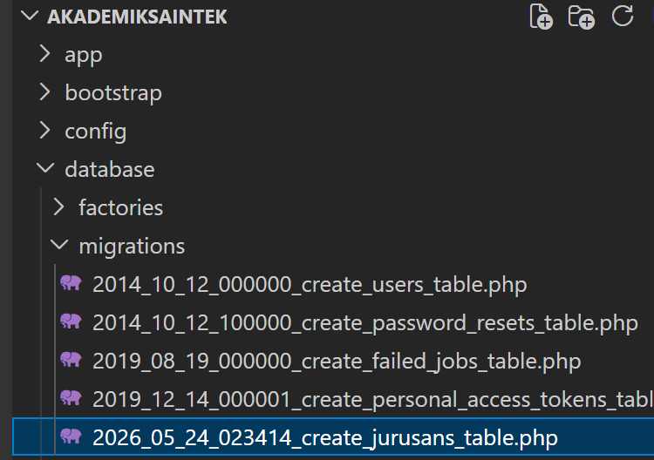
Pada function Up, sesuaikan coding di bawah ini:
public function up()
{
Schema::create('jurusans', function (Blueprint $table) {
$table->id();
$table->string('nama_jurusan');
$table->string('nama_dekan');
$table->integer('jumlah_mahasiswa');
$table->timestamps();
});
}

Lalu pada CMD jalankan:

Command php artisan migrate

🧱 STEP 3 — Tambahkan Pada Routes

Modifikasi file :routes/web.php

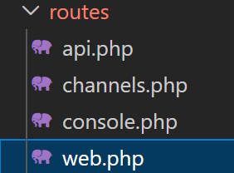

Sesuai code berikut:
Route::get('/daftar-jurusan', 'App\Http\Controllers\JurusanController@index')->middleware('auth');
Route::resource('jurusans', 'App\Http\Controllers\JurusanController')->middleware('auth');

Route::get('/', [App\Http\Controllers\HomeController::class, 'index'])->name('home');

🧱 STEP 4 — Modifikasi Model

Modifikasi file :Models/jurusan.php

Tambahkan : protected $guarded=[];

Code lengkapnya sbb:
class Jurusan extends Model
<?php

namespace App\Models;

use Illuminate\Database\Eloquent\Factories\HasFactory;
use Illuminate\Database\Eloquent\Model;

class Jurusan extends Model
{
use HasFactory;
protected $guarded = [];
}

🧱 STEP 5 — Modifikasi Controller Jurusan

Modifikasi file :Http/Controlles/JurusanController.php
class JurusanController extends Controller
{
/**
* Display a listing of the resource.
*
* @return \Illuminate\Http\Response
*/
public function index()
{
return view('jurusan.index', ['jurusans' => Jurusan::all()]);
}

/**
* Show the form for creating a new resource.
*
* @return \Illuminate\Http\Response
*/
public function create()
{
return view('jurusan.create');
}

/**
* Store a newly created resource in storage.
*
* @param \Illuminate\Http\Request $request
* @return \Illuminate\Http\Response
*/
public function store(Request $request)
{
$validateData = $request->validate([
'nama_jurusan' => 'required',
'nama_dekan' => 'required',
'jumlah_mahasiswa' => 'required|min:10|integer',
]);

Jurusan::create($validateData);
return redirect('/daftar-jurusan')->with('pesan', "Jurusan $request->nama_jurusan
berhasil ditambahkan");
}

/**
* Display the specified resource.
*
* @param \App\Jurusan $jurusan
* @return \Illuminate\Http\Response
*/
public function show(Jurusan $jurusan)
{
return view('jurusan.show', compact('jurusan'));
}

/**
* Show the form for editing the specified resource.
*
* @param \App\Jurusan $jurusan
* @return \Illuminate\Http\Response
*/
public function edit(Jurusan $jurusan)
{
return view('jurusan.edit', compact('jurusan'));
}

/**
* Update the specified resource in storage.
*
* @param \Illuminate\Http\Request $request
* @param \App\Jurusan $jurusan
* @return \Illuminate\Http\Response
*/
public function update(Request $request, Jurusan $jurusan)
{
$validateData = $request->validate([
'nama_jurusan' => 'required',
'nama_dekan' => 'required',
'jumlah_mahasiswa' => 'required|min:10|integer',
]);

$jurusan->update($validateData);

return redirect('/jurusans/' . $jurusan->id)
->with('pesan', "Jurusan $jurusan->nama_jurusan berhasil diupdate");
}

/**
* Remove the specified resource from storage.
*
* @param \App\Jurusan $jurusan
* @return \Illuminate\Http\Response
*/
public function destroy(Jurusan $jurusan)
{
$jurusan->delete();
return redirect('/daftar-jurusan')
->with('pesan', "Jurusan $jurusan->nama_jurusan berhasil dihapus");
}
}

🧱 STEP 6 — Modifikasi Auth Controller dan Layout
buka file app\Http\Controllers\Auth\RegisterController.php dan app\Http\Controllers\Auth\LoginController.php, lalu cari baris berikut:
protected $redirectTo = RouteServiceProvider::HOME;
Ubah menjadi:
protected $redirectTo = '/';
Sekarang setelah login dan register, user akan di redirect ke halaman root.

🧱 STEP 7 — Layout

modifikasi sedikit view layouts\app.blade.php .Tambah 2 buah menu baru di bagian navbar. Silahkan buka file ini dan cari blok komentar <!-- Left Side Of Navbar -->, lalu tambah kode berikut:

resources/views/layouts/app.blade.php <!-- Left Side Of Navbar -->
<ul class="navbar-nav mr-auto">
@auth
<li class="nav-item">
<a class="nav-link" href="{{url('/')}}">Jurusan</a>
</li>

@endauth
</ul>
Code lengkap views/layouts/app.blade.php sbb:
<!doctype html>
<html lang="{{ str_replace('_', '-', app()->getLocale()) }}">

<head>
<meta charset="utf-8">
<meta name="viewport" content="width=device-width, initial-scale=1">

<!-- CSRF Token -->
<meta name="csrf-token" content="{{ csrf_token() }}">

<title>{{ config('app.name', 'AKADEMIK') }}</title>
<!-- Bootstrap CSS -->
<link href="https://cdn.jsdelivr.net/npm/bootstrap@5.1.3/dist/css/bootstrap.min.css" rel="stylesheet">

</head>

<body>
<div id="app">
<nav class="navbar navbar-expand-md navbar-light bg-white shadow-sm">
<div class="container">
<a class="navbar-brand" href="{{ url('/') }}">
AKADEMIK SAINTEK
</a>
<button class="navbar-toggler" type="button" data-bs-toggle="collapse" data-bs-target="#navbarSupportedContent" aria-controls="navbarSupportedContent" aria-expanded="false" aria-label="{{ __('Toggle navigation') }}">
<span class="navbar-toggler-icon"></span>
</button>

<div class="collapse navbar-collapse" id="navbarSupportedContent">
<!-- Left Side Of Navbar -->
<ul class="navbar-nav me-auto">
@auth
<li class="nav-item">
<a class="nav-link" href="{{url('/jurusans')}}">Jurusan</a>
</li>
@endauth
</ul>

<!-- Right Side Of Navbar -->
<ul class="navbar-nav ms-auto">
<!-- Authentication Links -->
@guest
@if (Route::has('login'))
<li class="nav-item">
<a class="nav-link" href="{{ route('login') }}">{{ __('Login') }}</a>
</li>
@endif

@if (Route::has('register'))
<li class="nav-item">
<a class="nav-link" href="{{ route('register') }}">{{ __('Register') }}</a>
</li>
@endif
@else
<li class="nav-item dropdown">
<a id="navbarDropdown" class="nav-link dropdown-toggle" href="#" role="button" data-bs-toggle="dropdown" aria-haspopup="true" aria-expanded="false" v-pre>
{{ Auth::user()->name }}
</a>

<div class="dropdown-menu dropdown-menu-end" aria-labelledby="navbarDropdown">
<a class="dropdown-item" href="{{ route('logout') }}"
onclick="event.preventDefault();
document.getElementById('logout-form').submit();">
{{ __('Logout') }}
</a>

<form id="logout-form" action="{{ route('logout') }}" method="POST" class="d-none">
@csrf
</form>
</div>
</li>
@endguest
</ul>
</div>
</div>
</nav>

<main class="py-4">
@yield('content')
</main>
</div>
<script src="https://cdn.jsdelivr.net/npm/bootstrap@5.1.3/dist/js/bootstrap.bundle.min.js"></script>

</body>

</html>

Maka akan muncul menu baru Jurusan.

🧱 STEP 8 — Membuat View
Sama seperti di bab CRUD, kita perlu membuat 4 file view yang akan ditempatkan ke dalam folder jurusan di resources\views\. Berikut nama file yang akan kita buat:
■ index.blade.php
■ show.blade.php
■ create.blade.php
■ edit.blade.php

/views/jurusan/create.blade.php
@extends('layouts.app')

@section('content')
<div class="container mt-3">
<div class="row">
<div class="col-sm-8 col-md-6">
<h1 class="h2 pt-4">Pendaftaran Jurusan</h1>
<hr>

<form action="{{url('/jurusans')}}" method="POST">
@csrf
<div class="form-group">
<label for="nama_jurusan">Nama Jurusan</label>
<input type="text"
class="form-control @error('nama_jurusan') is-invalid @enderror"
id="nama_jurusan" name="nama_jurusan"
value="{{ old('nama_jurusan') }}">
@error('nama_jurusan')
<div class="text-danger">{{ $message }}</div>
@enderror
</div>

<div class="form-group">
<label for="nama_dekan">Nama Dekan</label>
<input type="text"
class="form-control @error('nama_dekan') is-invalid @enderror"
id="nama_dekan" name="nama_dekan" value="{{ old('nama_dekan') }}">
@error('nama_dekan')
<div class="text-danger">{{ $message }}</div>
@enderror
</div>

<div class="form-group">
<label for="jumlah_mahasiswa">Jumlah Mahasiswa</label>
<input type="text"
class="form-control @error('jumlah_mahasiswa') is-invalid @enderror"
id="jumlah_mahasiswa" name="jumlah_mahasiswa"
value="{{ old('jumlah_mahasiswa') }}">
@error('jumlah_mahasiswa')
<div class="text-danger">{{ $message }}</div>
@enderror
</div>

<button type="submit" class="btn btn-primary my-2">Daftar</button>
</form>

</div>
</div>
</div>

@endsection

Views/jurusan/edit.blade.php
@extends('layouts.app')

@section('content')
<div class="container mt-3">
<div class="row">
<div class="col-sm-8 col-md-6">
<h1 class="h2 pt-4">Edit Jurusan</h1>
<hr>

<form action="{{url('/jurusans/'.$jurusan->id)}}" method="POST">
@method('PATCH')
@csrf
<div class="form-group">
<label for="nama_jurusan">Nama Jurusan</label>
<input type="text"
class="form-control @error('nama_jurusan') is-invalid @enderror"
id="nama_jurusan" name="nama_jurusan"
value="{{ old('nim') ?? $jurusan->nama_jurusan }}">
@error('nama_jurusan')
<div class="text-danger">{{ $message }}</div>
@enderror
</div>

<div class="form-group">
<label for="nama_dekan">Nama Dekan</label>
<input type="text"
class="form-control @error('nama_dekan') is-invalid @enderror"
id="nama_dekan" name="nama_dekan"
value="{{ old('nim') ?? $jurusan->nama_dekan }}">
@error('nama_dekan')
<div class="text-danger">{{ $message }}</div>
@enderror
</div>

<div class="form-group">
<label for="jumlah_mahasiswa">Jumlah Mahasiswa</label>
<input type="text"
class="form-control @error('jumlah_mahasiswa') is-invalid @enderror"
id="jumlah_mahasiswa" name="jumlah_mahasiswa"
value="{{ old('nim') ?? $jurusan->jumlah_mahasiswa }}">
@error('jumlah_mahasiswa')
<div class="text-danger">{{ $message }}</div>
@enderror
</div>

<button type="submit" class="btn btn-primary my-2">Update</button>
</form>

</div>
</div>
</div>
@endsection

Vies/jurusan/index.blade.php
@extends('layouts.app')

@section('content')
<div class="container mt-3">
<div class="row">
<div class="col-12">

<div class="py-4 d-flex justify-content-end align-items-center">
<h1 class="h2 mr-auto">Tabel Jurusan</h1>
<a href="{{url('/jurusans/create')}}" class="btn btn-primary">
Tambah Jurusan
</a>
</div>

@if(session()->has('pesan'))
<div class="alert alert-success" role="alert">
{{ session()->get('pesan')}}
</div>
@endif

<table class="table table-striped">
<thead>
<tr>
<th>#</th>
<th>Nama Jurusan</th>
<th>Nama Dekan</th>
<th>Jumlah Mahasiswa</th>
</tr>
</thead>
<tbody>
@forelse ($jurusans as $jurusan)
<tr>
<th>{{$loop->iteration}}</th>
<td>
<a href="{{ url('/jurusans/'.$jurusan->id) }}">
{{$jurusan->nama_jurusan}}
</a>
</td>
<td>{{$jurusan->nama_dekan}}</td>
<td>{{$jurusan->jumlah_mahasiswa}}</td>
</tr>
@empty
<td colspan="6" class="text-center">Tidak ada data...</td>
@endforelse
</tbody>
</table>
</div>
</div>
</div>
@endsection

View/jurusan/show.blade.php
@extends('layouts.app')

@section('content')

<div class="container mt-3">
<div class="row">
<div class="col-12">

<div class="pt-4 d-flex justify-content-end align-items-center">
<h1 class="h2 mr-auto">Info Jurusan {{$jurusan->nama_jurusan}}</h1>
<a href="{{url('/jurusans/'.$jurusan->id.'/edit')}}"
class="btn btn-primary">Edit</a>
<form action="{{url('/jurusans/'.$jurusan->id)}}" method="POST">
@method('DELETE')
<button type="submit" class="btn btn-danger ml-3">Hapus</button>
@csrf
</form>
</div>
<hr>

@if(session()->has('pesan'))
<div class="alert alert-success" role="alert">
{{ session()->get('pesan')}}
</div>
@endif

<ul>
<li>Nama Jurusan: {{$jurusan->nama_jurusan}} </li>
<li>Nama Dekan: {{$jurusan->nama_dekan}} </li>
<li>Jumlah Mahasiswa: {{$jurusan->jumlah_mahasiswa}} </li>
</ul>
</div>
</div>
</div>

@endsection

🧱 STEP 10 — Jalankan Laravel
php artisan serve
Buka browser dan jalankan melalui link berikut:
http://127.0.0.1:8000 atau

http://localhost:8000

- MEMBUAT MENU MAHASISWA

🧱 STEP 1 — Membuat Migration
Masuk CMD dan buat file otomatis bagian --migration --controller –resource(mcr) dengan command berikut:
Commandphp artisan make:model Mahasiswa –mcr

🧱 STEP 2 —
Buka file: database\migration\xxxxxcreate_mahasiswatable.php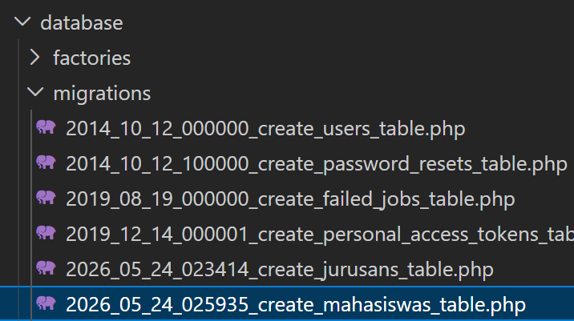

Lalu sesuaikan coding di bawah ini:

public function up()
{
Schema::create('mahasiswas', function (Blueprint $table) {
$table->id();
$table->char('nim',8)->unique();
$table->string('nama');
$table->char('jenis_kelamin',1);
$table->foreignId('jurusan_id')->constrained('jurusans')->onDelete('cascade');
$table->text('alamat')->nullable();

$table->timestamps();
});
}

Buka CMD lalu jalankan:

Commandphp artisan migrate

🧱 STEP 3 — Tambahkan Pada Routes
Route::get('/mahasiswas', 'App\Http\Controllers\MahasiswaController@index')->middleware('auth');
Route::resource('mahasiswas', 'App\Http\Controllers\MahasiswaController')->middleware('auth');

🧱 STEP 4 — Modifikasi Model

Buka file app/Models/Mahasiswa.php lalu modifikasi isinya:
<?php

namespace App\Models;

use Illuminate\Database\Eloquent\Factories\HasFactory;
use Illuminate\Database\Eloquent\Model;
use App\Models\Jurusan;

class Mahasiswa extends Model
{
use HasFactory;
protected $guarded = [];
public function jurusan()
{
return $this->belongsTo(Jurusan::class);
// return $this->belongsTo(Jurusan::class, 'jurusan_id');
}
}

🧱 STEP 5 — Modifikasi Controller Mahasiswa
<?php

namespace App\Http\Controllers;

use App\Models\Mahasiswa;
use App\Models\Jurusan;
use Illuminate\Http\Request;

class MahasiswaController extends Controller
{
public function index()
{

$mahasiswas = Mahasiswa::with('jurusan')->get();

return view('mahasiswa.index', compact('mahasiswas'));
// $mahasiswas = Mahasiswa::all();

}

public function create()
{
$jurusans = Jurusan::all();
return view('mahasiswa.create', compact('jurusans'));
// return view('mahasiswa.create');
}

public function store(Request $request)
{
$validateData = $request->validate([
'nim' => 'required|size:8|unique:mahasiswas',
'nama' => 'required|min:3|max:50',
'jenis_kelamin' => 'required|in:P,L',
'jurusan_id' => 'required',
'alamat' => '',
]);

Mahasiswa::create($validateData);

return redirect()->route('mahasiswas.index')->with('pesan', "Penambahan data {$validateData['nama']} berhasil");
}

public function show(Mahasiswa $mahasiswa)
{
return view('mahasiswa.show', ['mahasiswa' => $mahasiswa]);
}

public function edit(Mahasiswa $mahasiswa)
{
$jurusans = Jurusan::all();
return view('mahasiswa.edit', compact('mahasiswa', 'jurusans'));
// return view('mahasiswa.edit', ['mahasiswa' => $mahasiswa]);
}

public function update(Request $request, Mahasiswa $mahasiswa)
{
$validateData = $request->validate([
'nim' => 'required|size:8|unique:mahasiswas,nim,' . $mahasiswa->id,
'nama' => 'required|min:3|max:50',
'jenis_kelamin' => 'required|in:P,L',
'jurusan_id' => 'required',
'alamat' => '',
]);

$mahasiswa->update($validateData);

return redirect()->route('mahasiswas.show', ['mahasiswa' => $mahasiswa->id])
->with('pesan', "Update data {$validateData['nama']} berhasil");
}

public function destroy(Mahasiswa $mahasiswa)
{
$mahasiswa->delete();
return redirect()->route('mahasiswas.index')
->with('pesan', "Hapus data $mahasiswa->nama berhasil");
}
}

🧱 STEP 6 — Modifikasi Auth Controller dan Layout
buka file app\Http\Controllers\Auth\RegisterController.php dan app\Http\Controllers\Auth\LoginController.php, lalu cari baris berikut:
protected $redirectTo = RouteServiceProvider::HOME;
Ubah menjadi:
protected $redirectTo = '/';
Sekarang setelah login dan register, user akan di redirect ke halaman root.

🧱 STEP 7 — Modifikasi Layout Menu Mahasiswa

modifikasi sedikit view layouts\app.blade.php. Tambahkan menu baru di bagian navbar. Silahkan buka file ini dan cari blok komentar <!-- Left Side Of Navbar -->, lalu tambah kode berikut:
resources/views/layouts/app.blade.php <!-- Left Side Of Navbar -->
<ul class="navbar-nav mr-auto"> @auth
...
<li class="nav-item">
<a class="nav-link" href="{{url('/mahasiswas')}}"> Mahasiswa</a>
</li>

@endauth
</ul>
<div class="collapse navbar-collapse" id="navbarSupportedContent">
<!-- Left Side Of Navbar -->
<ul class="navbar-nav me-auto">
@auth
<li class="nav-item">
<a class="nav-link" href="{{url('/jurusans')}}">Jurusan</a>
</li>
<li class="nav-item">
<a class="nav-link" href="{{url('/mahasiswas')}}">Mahasiswa</a>
</li>

@endauth

</ul>

🧱 STEP 8 — Membuat View
Sama seperti di bab CRUD, kita perlu membuat 4 file view yang akan ditempatkan ke dalam folder mahasiswa di resources\views\. Berikut nama file yang akan kita buat:
■ index.blade.php
■ show.blade.php
■ create.blade.php
■ edit.blade.php

/views/jurusan/create.blade.php
@extends('layouts.app')

@section('content')

<div class="container pt-4 bg-white">
<div class="row">
<div class="col-md-8 col-xl-6">
<h1>Pendaftaran Mahasiswa</h1>
<hr>

<form action="{{ route('mahasiswas.store') }}" method="POST">
@csrf
<div class="form-group">
<label for="nim">NIM</label>
<input type="text"
class="form-control @error('nim') is-invalid @enderror"
id="nim" name="nim" value="{{ old('nim') }}">
@error('nim')
<div class="text-danger">{{ $message }}</div>
@enderror
</div>

<div class="form-group">
<label for="nama">Nama Lengkap</label>
<input type="text"
class="form-control @error('nama') is-invalid @enderror"
id="nama" name="nama" value="{{ old('nama') }}">
@error('nama')
<div class="text-danger">{{ $message }}</div>
@enderror
</div>

<div class="form-group">
<label>Jenis Kelamin</label>
<div>
<div class="form-check form-check-inline">
<input class="form-check-input" type="radio" name="jenis_kelamin"
id="laki_laki" value="L"
{{ old('jenis_kelamin')=='L' ? 'checked': '' }}>
<label class="form-check-label" for="laki_laki">Laki-laki</label>
</div>
<div class="form-check form-check-inline">
<input class="form-check-input" type="radio" name="jenis_kelamin"
id="perempuan" value="P"
{{ old('jenis_kelamin')=='P' ? 'checked': '' }}>
<label class="form-check-label" for="perempuan">Perempuan</label>
</div>
@error('jenis_kelamin')
<div class="text-danger">{{ $message }}</div>
@enderror
</div>
</div>

<!-- <div class="form-group">
<label for="jurusan">Jurusan</label>
<select class="form-control" name="jurusan" id="jurusan">
<option value="Teknik Informatika"
{{ old('jurusan')=='Teknik Informatika' ? 'selected': '' }} >
Teknik Informatika
</option>
<option value="Sistem Informasi"
{{ old('jurusan')=='Sistem Informasi' ? 'selected': '' }} >
Sistem Informasi
</option>
<option value="Ilmu Komputer"
{{ old('jurusan')=='Ilmu Komputer' ? 'selected': '' }} >
Ilmu Komputer
</option>
<option value="Teknik Komputer"
{{ old('jurusan')=='Teknik Komputer' ? 'selected': '' }} >
Teknik Komputer
</option>
<option value="Teknik Telekomunikasi"
{{ old('jurusan')=='Teknik Telekomunikasi' ? 'selected': '' }} >
Teknik Telekomunikasi
</option>
</select>
@error('jurusan')
<div class="text-danger">{{ $message }}</div>
@enderror
</div> -->
<div class="col-md-6 mb-3">
<label for="jurusan_id" class="form-label">Jurusan *</label>
<select class="form-select @error('jurusan_id') is-invalid @enderror"
id="jurusan_id" name="jurusan_id" required>
<option value="">Pilih Jurusan</option>
@foreach($jurusans as $jurusan)
<option value="{{ $jurusan->id }}"
{{ old('jurusan_id', $mahasiswa->jurusan_id ?? '') == $jurusan->id ? 'selected' : '' }}>
{{ $jurusan->nama_jurusan }}
</option>
@endforeach
</select>
@error('jurusan_id')
<div class="invalid-feedback">{{ $message }}</div>
@enderror
</div>

<div class="form-group">
<label for="alamat">Alamat</label>
<textarea class="form-control" id="alamat" rows="3"
name="alamat">{{ old('alamat') }}</textarea>
</div>

<button type="submit" class="btn btn-primary mb-2">Daftar</button>
</form>

</div>
</div>
</div>

@endsection

Views/jurusan/edit.blade.php
@extends('layouts.app')

@section('content')

<div class="container pt-4 bg-white">
<div class="row">
<div class="col-md-8 col-xl-6">
<h1>Edit Mahasiswa</h1>
<hr>

<form action="{{ route('mahasiswas.update',['mahasiswa' => $mahasiswa->id]) }}" method="POST">
@method('PATCH')
@csrf
<div class="form-group">
<label for="nim">NIM</label>
<input type="text"
class="form-control @error('nim') is-invalid @enderror"
id="nim" name="nim" value="{{ old('nim') ?? $mahasiswa->nim }}">
@error('nim')
<div class="text-danger">{{ $message }}</div>
@enderror
</div>

<div class="form-group">
<label for="nama">Nama Lengkap</label>
<input type="text"
class="form-control @error('nama') is-invalid @enderror"
id="nama" name="nama" value="{{ old('nama') ?? $mahasiswa->nama }}">
@error('nama')
<div class="text-danger">{{ $message }}</div>
@enderror
</div>

<div class="form-group">
<label>Jenis Kelamin</label>
<div>
<div class="form-check form-check-inline">
<input class="form-check-input" type="radio" name="jenis_kelamin"
id="laki_laki" value="L"
{{ (old('jenis_kelamin') ?? $mahasiswa->jenis_kelamin)
== 'L' ? 'checked': '' }}>
<label class="form-check-label" for="laki_laki">Laki-laki</label>
</div>
<div class="form-check form-check-inline">
<input class="form-check-input" type="radio" name="jenis_kelamin"
id="perempuan" value="P"
{{ (old('jenis_kelamin') ?? $mahasiswa->jenis_kelamin)
== 'P' ? 'checked': '' }}>
<label class="form-check-label" for="perempuan">Perempuan</label>
</div>
@error('jenis_kelamin')
<div class="text-danger">{{ $message }}</div>
@enderror
</div>
</div>

<!-- <div class="form-group">
<label for="jurusan">Jurusan</label>
<select class="form-control" name="jurusan" id="jurusan">
<option value="Teknik Informatika"
{{ (old('jurusan') ?? $mahasiswa->jurusan)==
'Teknik Informatika' ? 'selected': '' }} >
Teknik Informatika
</option>
<option value="Sistem Informasi"
{{ (old('jurusan') ?? $mahasiswa->jurusan)==
'Sistem Informasi' ? 'selected': '' }} >
Sistem Informasi
</option>
<option value="Ilmu Komputer"
{{ (old('jurusan') ?? $mahasiswa->jurusan)==
'Ilmu Komputer' ? 'selected': '' }} >
Ilmu Komputer
</option>
<option value="Teknik Komputer"
{{ (old('jurusan') ?? $mahasiswa->jurusan)==
'Teknik Komputer' ? 'selected': '' }} >
Teknik Komputer
</option>
<option value="Teknik Telekomunikasi"
{{(old('jurusan')??$mahasiswa->jurusan)==
'Teknik Telekomunikasi'?'selected':''}} >
Teknik Telekomunikasi
</option>
</select>
@error('jurusan')
<div class="text-danger">{{ $message }}</div>
@enderror
</div> -->
<div class="col-md-6 mb-3">
<label for="jurusan_id" class="form-label">Jurusan *</label>
<select class="form-select @error('jurusan_id') is-invalid @enderror"
id="jurusan_id" name="jurusan_id" required>
<option value="">Pilih Jurusan</option>
@foreach($jurusans as $jurusan)
<option value="{{ $jurusan->id }}"
{{ old('jurusan_id', $mahasiswa->jurusan_id ?? '') == $jurusan->id ? 'selected' : '' }}>
{{ $jurusan->nama_jurusan }}
</option>
@endforeach
</select>
@error('jurusan_id')
<div class="invalid-feedback">{{ $message }}</div>
@enderror
</div>

<div class="form-group">
<label for="alamat">Alamat</label>
<textarea class="form-control" id="alamat" rows="3"
name="alamat">{{ old('alamat') ?? $mahasiswa->alamat}}</textarea>
</div>

<button type="submit" class="btn btn-primary mb-2">Update</button>
</form>

</div>
</div>
</div>

@endsection

Vies/jurusan/index.blade.php
@extends('layouts.app')

@section('content')

<div class="container mt-3">
<div class="row">

<div class="col-12">

<div class="py-4 d-flex justify-content-end align-items-center">
<h2 class="mr-auto">Tabel Mahasiswa</h2>
<a href="{{ route('mahasiswas.create') }}" class="btn btn-primary">
Tambah Mahasiswa
</a>
</div>

@if(session()->has('pesan'))
<div class="alert alert-success">
{{ session()->get('pesan')}}
</div>
@endif

<table class="table table-striped">
<thead>
<tr>
<th>#</th>
<th>Nim</th>
<th>Nama</th>
<th>Jenis Kelamin</th>
<th>Jurusan</th>
<th>Alamat</th>
</tr>
</thead>
<tbody>
@forelse ($mahasiswas as $mahasiswa)
<tr>
<th>{{$loop->iteration}}</th>
<td><a href="{{ route('mahasiswas.show',['mahasiswa' => $mahasiswa->id]) }}">{{$mahasiswa->nim}}</a></td>
<td>{{$mahasiswa->nama}}</td>
<td>{{$mahasiswa->jenis_kelamin == 'P'?'Perempuan':'Laki-laki'}}</td>
<!-- <td>{{$mahasiswa->jurusan}}</td> -->
<td>
@if($mahasiswa->jurusan)
{{ $mahasiswa->jurusan->nama_jurusan }}
@endif
</td>
<td>{{$mahasiswa->alamat == '' ? 'N/A' : $mahasiswa->alamat}}</td>
</tr>
@empty
<td colspan="6" class="text-center">Tidak ada data...</td>
@endforelse
</tbody>
</table>
</div>
</div>
</div>

@endsection

View/jurusan/show.blade.php
@extends('layouts.app')

@section('content')

<div class="container mt-3">
<div class="row">
<div class="col-12">

<div class="pt-3 d-flex justify-content-end align-items-center">
<h1 class="h2 mr-auto">Biodata {{$mahasiswa->nama}}</h1>
<a href="{{ route('mahasiswas.edit',['mahasiswa' => $mahasiswa->id]) }}"
class="btn btn-primary">Edit</a>

<form action="{{ route('mahasiswas.destroy',['mahasiswa' => $mahasiswa->id]) }}"
method="POST">
@method('DELETE')
@csrf
<button type="submit" class="btn btn-danger ml-3">Hapus</button>
</form>

</div>

<hr>

@if(session()->has('pesan'))
<div class="alert alert-success" role="alert">
{{ session()->get('pesan')}}
</div>
@endif

<ul>
<li>NIM: {{$mahasiswa->nim}} </li>
<li>Nama: {{$mahasiswa->nama}} </li>
<li>Jenis Kelamin:
{{$mahasiswa->jenis_kelamin == 'P' ? 'Perempuan' : 'Laki-laki'}}
</li>
<li>Jurusan: {{$mahasiswa->jurusan->nama_jurusan}} </li>
<li>Alamat:
{{$mahasiswa->alamat == '' ? 'N/A' : $mahasiswa->alamat}}
</li>
</ul>

</div>
</div>
</div>

@endsection

🧱 STEP 10 — Jalankan Laravel
php artisan serve
Buka browser dan jalankan melalui link berikut:
http://127.0.0.1:8000 atau

http://localhost:8000

